Supplementary information
Pressure-induced metallization of dense (H₂S)₂H₂ with high-T_{c} superconductivity
Defang Duan^{1,2}, Yunxian Liu¹, Fubo Tian¹, Da Li¹, Xiaoli Huang¹, Zhonglong Zhao¹, Hongyu Yu¹, Bingbing Liu¹, Wenjing Tian² & Tian Cui¹
¹State Key Laboratory of Superhard Materials, College of physics, Jilin University, Changchun, 130012, P. R. China, ²State Key Laboratory of Supramolecular Structure and Materials, Jilin University, Changchun, 130012, P. R. China.
Computational details
The structure searching simulations were performed with the USPEX code¹⁻³. This method employed here are designed requiring only chemical compositions for a given compound to search for stable or metastable structures at given pressure conditions. The effectiveness of the USPEX method has been demonstrated by the successful applications in predicting high-pressure structures of various systems⁴⁻⁶. Typically, the structure searching simulation for each calculation reaches the convergence after we generated 1000 to 1500 structures (e.g., about 20~30 generations).
The underlying structure relaxations were performed with VASP code⁷. In the geometrical optimization, all forces on atoms were converged to less than 0.001 eV∕Å, and the total stress tensor was reduced to the order of 0.01 GPa. For band structures and electronic density of states calculation, a denser k-point mesh with 2π × 0.015 Å⁻¹ was chosen to ensure the convergence of the results.
Lattice dynamics calculations were performed with QUANTUM-ESPRESSO code⁸. The q-point meshes of 3 × 3 × 3 for P1 and 3 × 3 × 4 for Cccm structures are used in the interpolation of the force constants for the phonon dispersion curve calculations. The Monkhorst-Pack k-point meshes of 6 × 6 × 6 and 6 × 6 × 8 are used for the two structures accordingly. Phonon dispersions of P1 and Cccm structures were also performed by using supercell method⁹ implemented in Phononpy code¹⁰. The absence of any imaginary frequency confirms the dynamic stability of the P1 and Cccm phases. Raman spectra of the P1 structure were calculated using density functional perturbation theory¹¹ and plane-wave pseudopotential method with norm-conserving potentials¹², as implemented in the CASTEP code^{13,14}. The Perdew-Burke-Ernzerhof parameterization of the generalized gradient approximation was used¹⁵. Convergence tests gave a suitable value of 1000 eV kinetic energy cutoff and Monkhorst-Pack k-point mesh of 6 × 6 × 7.

Table S1 | Structure parameters of our predicted P1, Cccm, R3m and Im-3m structures of (H₂S)₂H₂ at high pressure.
Space group | Lattice parameters  (Å, °) | Atom | Atomic coordinates (fractional)
Space group | Lattice parameters  (Å, °) | Atom | x | y | z
P1 | a=6.389 | H(1a) | 0.92457 | 0.38786 | 0.29530
(20 GPa) | b=6.432 | H(1a) | 0.00261 | 0.14623 | 0.03861
 | c=5.355 | H(1a) | 0.40004 | 0.26485 | 0.96399
 | α=90.119 | H(1a) | 0.40262 | 0.95238 | 0.46910
 | β=89.846 | H(1a) | 0.50005 | 0.26396 | 0.47023
 | γ=90.148 | H(1a) | 0.67744 | 0.13982 | 0.75094
 |  | H(1a) | 0.92812 | 0.14383 | 0.54883
 |  | H(1a) | 0.22531 | 0.07730 | 0.74638
 |  | H(1a) | 0.50124 | 0.94154 | 0.96071
 |  | H(1a) | 0.99555 | 0.07360 | 0.47066
 |  | H(1a) | 0.91416 | 0.07729 | 0.99809
 |  | H(1a) | 0.92385 | 0.83337 | 0.78401
 |  | H(1a) | 0.10710 | 0.55336 | 0.06222
 |  | H(1a) | 0.98855 | 0.38339 | 0.77822
 |  | H(1a) | 0.79069 | 0.55804 | 0.56662
 |  | H(1a) | 0.79976 | 0.65025 | 0.06753
 |  | H(1a) | 0.21715 | 0.76032 | 0.28274
 |  | H(1a) | 0.11584 | 0.65185 | 0.57573
 |  | H(1a) | 0.70121 | 0.08778 | 0.25899
 |  | H(1a) | 0.48859 | 0.56585 | 0.04182
 |  | H(1a) | 0.40846 | 0.62848 | 0.97255
 |  | H(1a) | 0.47515 | 0.63586 | 0.58176
 |  | H(1a) | 0.42349 | 0.57357 | 0.48049
 |  | H(1a) | 0.58664 | 0.79555 | 0.26532
 |  | S(1a) | 0.28814 | 0.28218 | 0.74524
 |  | S(1a) | 0.61922 | 0.28363 | 0.25222
 |  | S(1a) | 0.28961 | 0.95682 | 0.24969
 |  | S(1a) | 0.62800 | 0.92949 | 0.75046
 |  | S(1a) | 0.13278 | 0.77799 | 0.78356
 |  | S(1a) | 0.13456 | 0.43572 | 0.27545
 |  | S(1a) | 0.79735 | 0.76966 | 0.28356
 |  | S(1a) | 0.77902 | 0.43757 | 0.78203
Cccm | a=8.157 | H(16m) | 0.33285 | 0.66798 | 0.24948
(60 GPa) | b=8.181 | H(8i) | 0.00000 | 0.00000 | 0.32870
 | c=4.830 | H(8l) | 0.60704 | 0.16145 | 0.50000
 |  | H(8g) | 0.54552 | 0.00000 | 0.25000
 |  | H(8l) | 0.33837 | 0.89039 | 0.00000
 |  | S(8l) | 0.75864 | 0.07766 | 0.50000
 |  | S(8l) | 0.42337 | 0.74171 | 0.00000
R3m | a=4.405 | H(9b) | 0.51430 | 0.02860 | 0.29941
(130 GPa) | c=2.689 | S(3a) | 0.66667 | 0.33333 | 0.62631
Im-3m | a= 2.984 | H(6b) | 0.00000 | 0.50000 | 0.50000
(200 GPa) |  | S(2a) | 0.50000 | 0.50000 | 0.50000

Figure S1 | Phonon dispersion curves of (a) P1 at 30 GPa and (b) Cccm at 80 GPa along the high symmetry directions of the Brillouin zone.
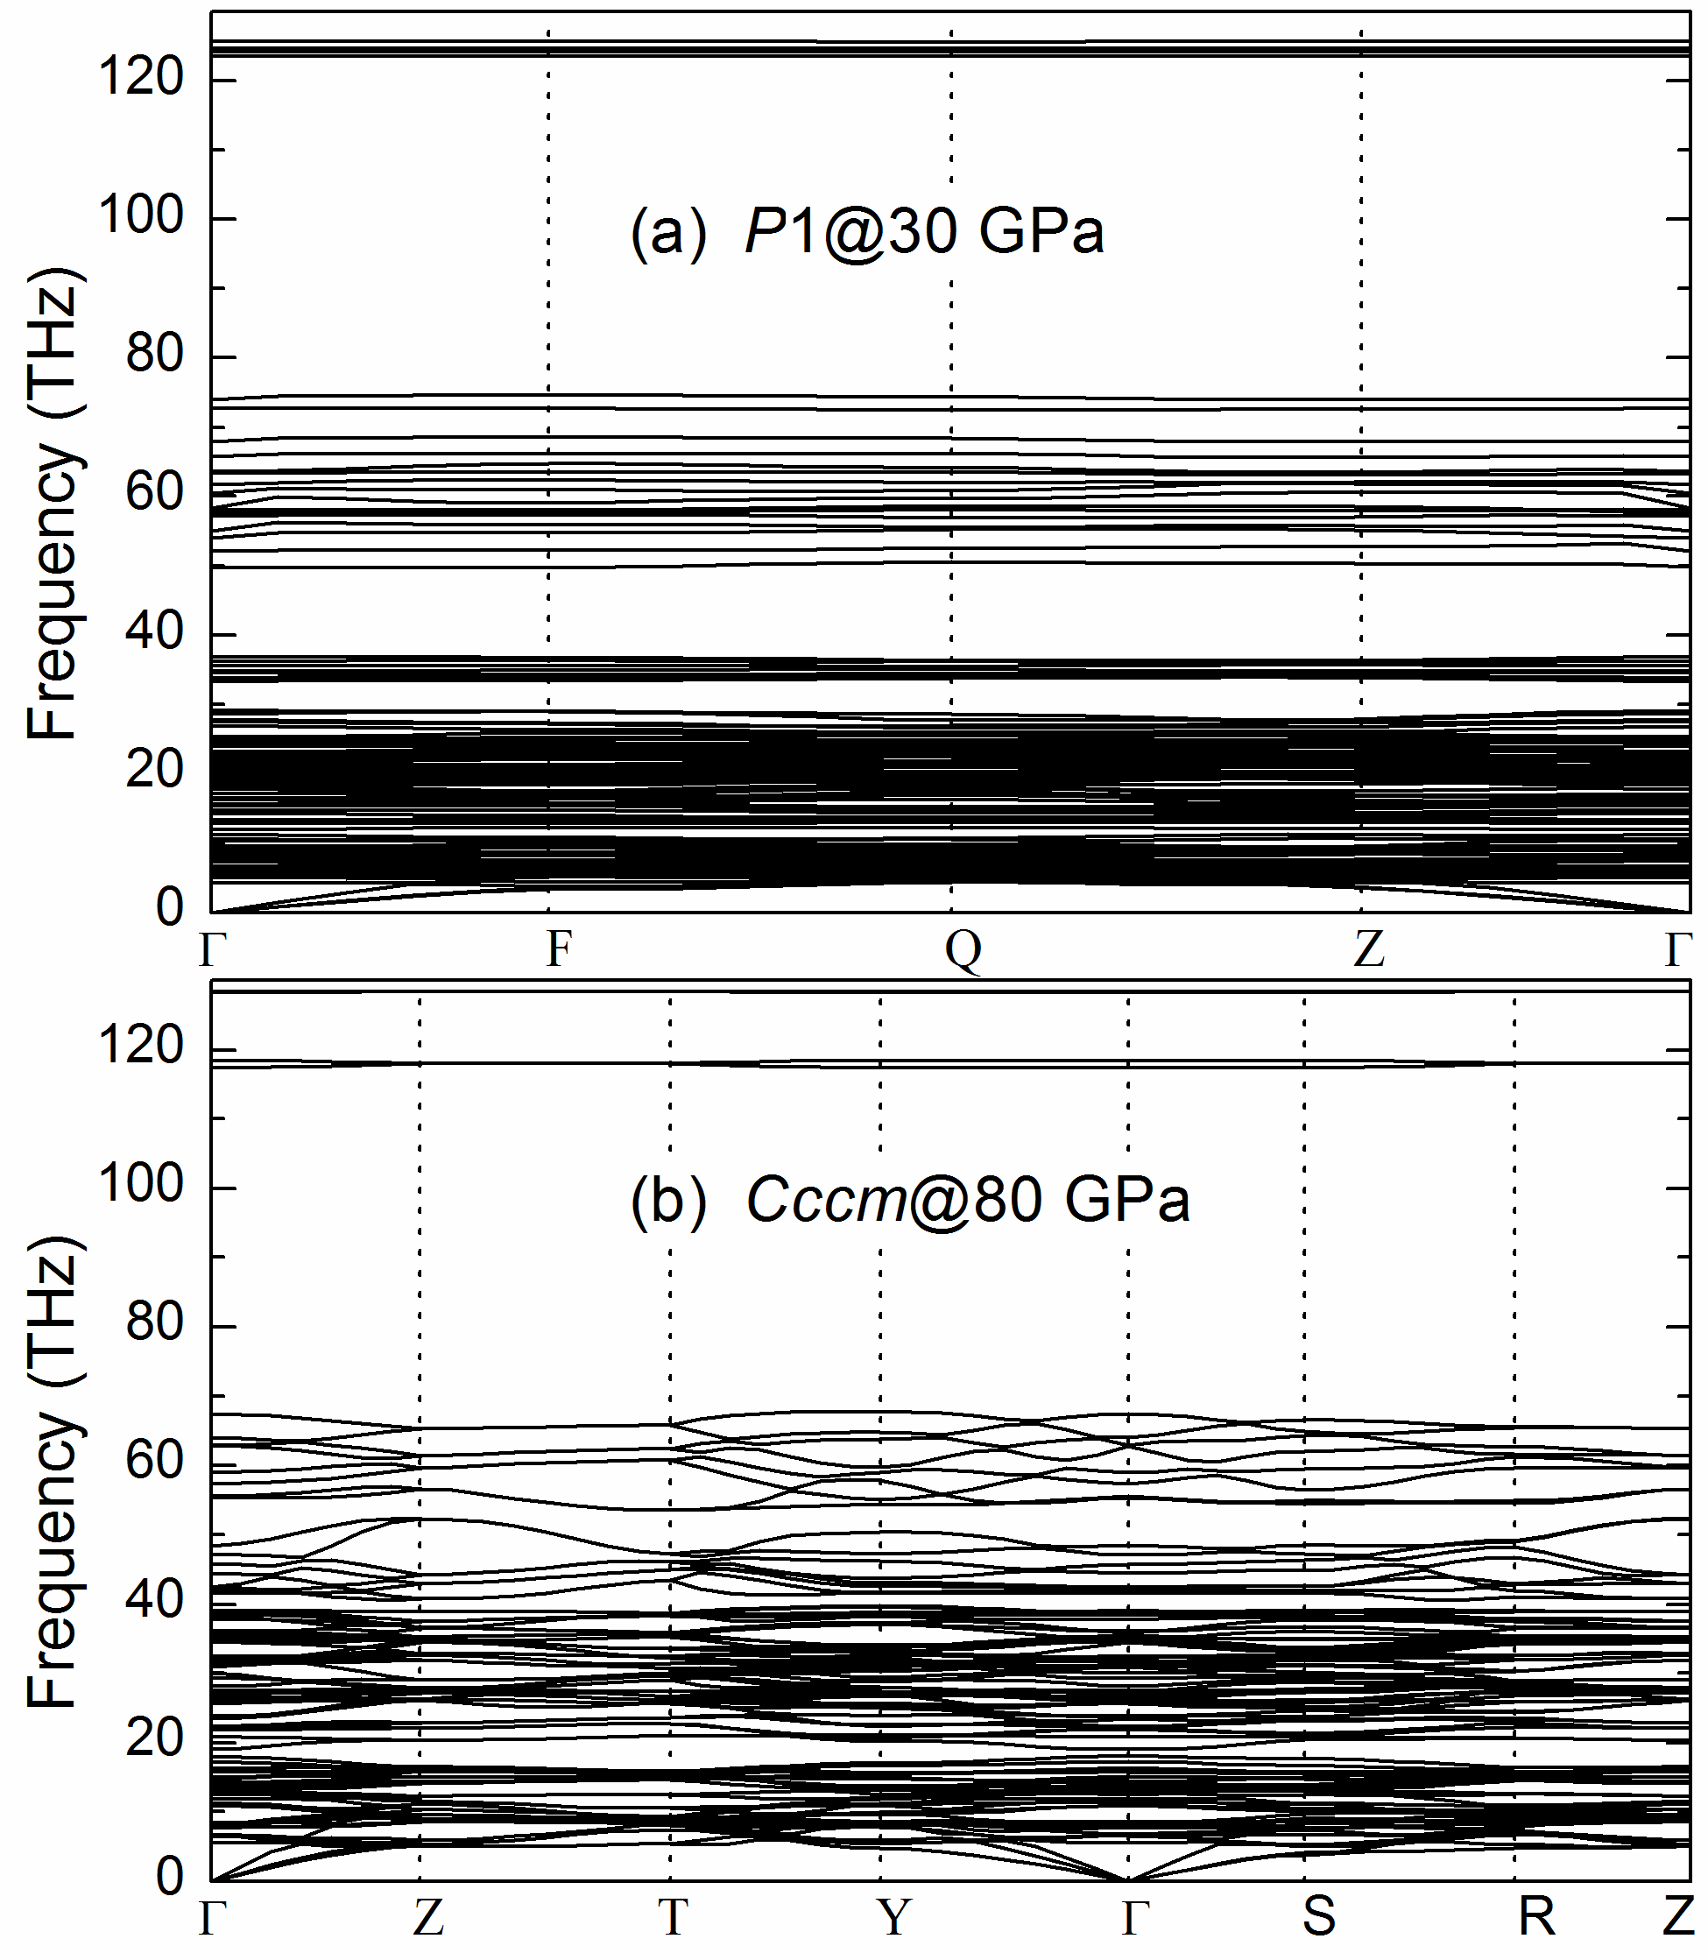
Figure S2 | Calculated Raman spectra for the P1 structures (red line denots broadening 15 cm⁻¹ and dark yellow line with broadening 100 cm⁻¹) along with experimental data.
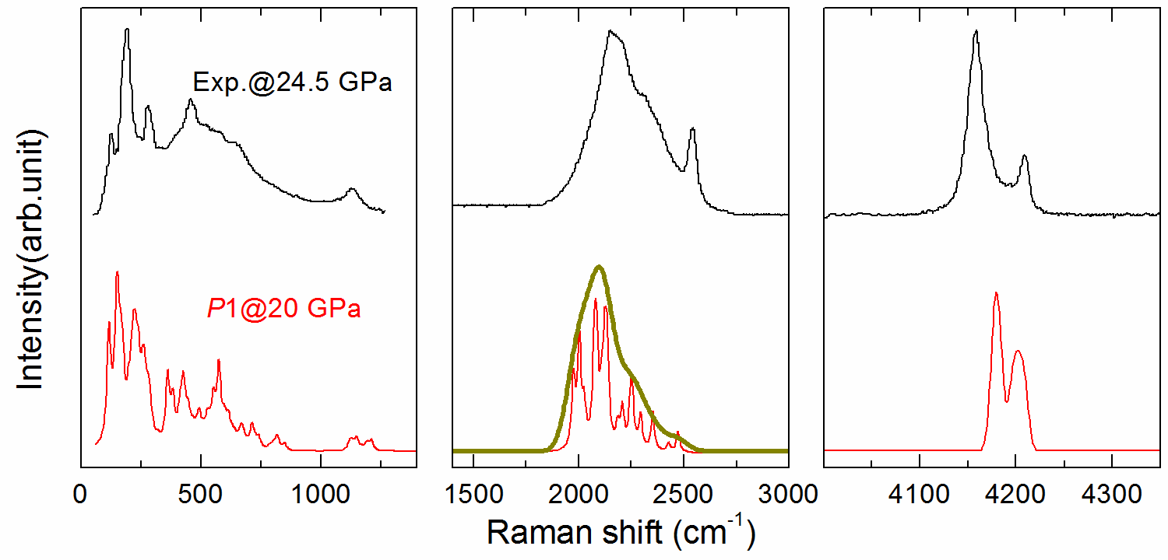
Figure S3 | (a) Electronic band structure for (a) P1 at 20 GPa and (b) Cccm at 60 GPa along the selected high symmetry lines and atom-projected DOS, where the dotted lines at zero indicate the Fermi level. (c) Calculated magnitudes of the bandgap for P1 and Cccm structures as a function of pressure.
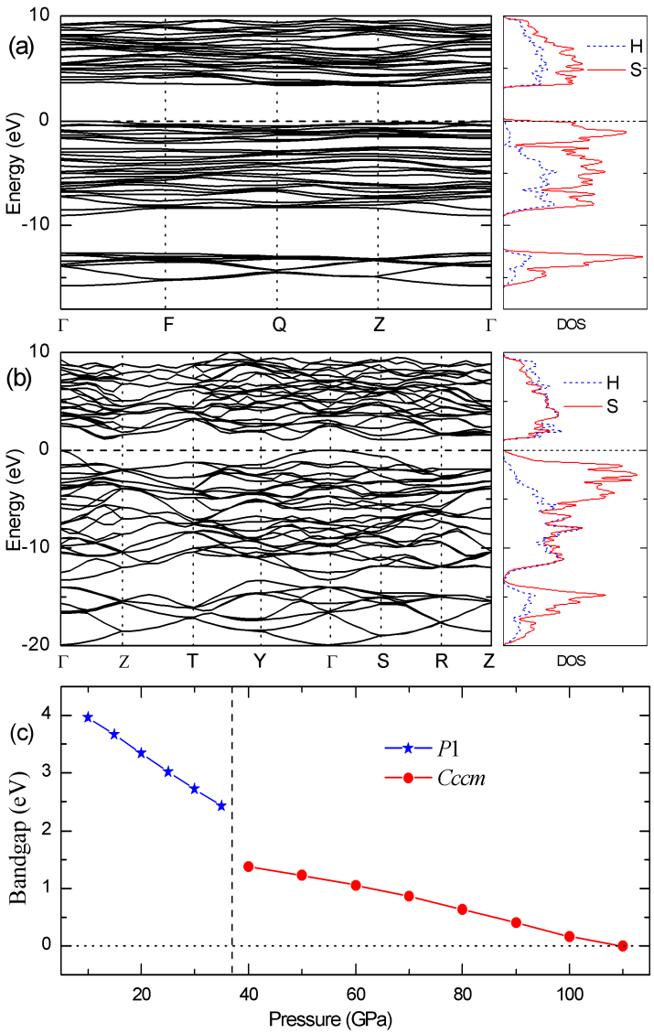

Supplementary References
1 Oganov, A. R. & Glass, C. W. Crystal structure prediction using ab initio evolutionary techniques: Principles and applications. J. Chem. Phys. 124, 244704-244715 (2006).
2 Oganov, A. R., Lyakhov, A. O. & Valle, M. How Evolutionary Crystal Structure Prediction Works—and Why. Acc. Chem. Res. 44, 227-237 (2011).
3 Lyakhov, A. O., Oganov, A. R., Stokes, H. T. & Zhu, Q. New developments in evolutionary structure prediction algorithm USPEX. Comput. Phys. Commun. 184, 1172-1182 (2013).
4 Oganov, A. R. et al. Ionic high-pressure form of elemental boron. Nature 457, 863-867 (2009).
5 Ma, Y. et al. Transparent dense sodium. Nature 458, 182-185 (2009).
6 Zhang, W. et al. Unexpected stable stoichiometries of sodium chlorides. Science 342, 1502-1505 (2013).
7 Kresse, G. & Furthmüller, J. Efficient iterative schemes for ab initio total-energy calculations using a plane-wave basis set. Phys. Rev. B 54, 11169-11186 (1996).
8 Paolo, G. et al. QUANTUM ESPRESSO: a modular and open-source software project for quantum simulations of materials. J. Phys.: Condens. Matter 21, 395502 (2009).
9 Parlinski, K., Li, Z. Q. & Kawazoe, Y. First-Principles Determination of the Soft Mode in Cubic ZrO₂. Phys. Rev. Lett. 78, 4063-4066 (1997).
10 Togo, A., Oba, F. & Tanaka, I. First-principles calculations of the ferroelastic transition between rutile-type and CaCl₂-type SiO₂ at high pressures. Phys. Rev. B 78, 134106 (2008).
11 Baroni, S., de Gironcoli, S., Dal Corso, A. & Giannozzi, P. Phonons and related crystal properties from density-functional perturbation theory. Rev. Mod. Phys. 73, 515-562 (2001).
12 Troullier, N. & Martins, J. L. Efficient pseudopotentials for plane-wave calculations. Phys. Rev. B 43, 1993 (1991).
13 Clark Stewart, J. et al. First principles methods using CASTEP. Z. Kristallogr. 220, 567 (2005).
14 Refson, K., Tulip, P. R. & Clark, S. J. Variational density-functional perturbation theory for dielectrics and lattice dynamics. Phys. Rev. B 73, 155114 (2006).
15 Perdew, J. P., Burke, K. & Ernzerhof, M. Generalized Gradient Approximation Made Simple. Phys. Rev. Lett. 77, 3865-3868 (1996).

